[’26 FE] Design of Secure Remote Diag on Container Separation Architecture
Table of Contents
1. About This Document 3
2. Introduction 4
2.1. Purpose 4
2.2. Audience 4
2.3. Abbreviations / Terms 4
2.4. Related Documents 5
3. Context 6
3.1. Software context 6
3.2. System architecture migration 6
4. Problem 7
4.1. Functional requirements 7
4.2. Problem identification 7
4.2.1. Problem description 7
4.2.2. Problem analysis 8
4.3. Quality Attributes 8
5. Architecture Alternatives 9
5.1. Alt-A: Split RemoteDiag 9
5.2. Alt-B: Move RemoteDiag 10
5.3. Alt-C: Move RemoteDiag + Proxy 10
5.4. Comparison and decision 11
6. Implementation and Verification 12
6.1. Implementation 12
6.1.1. Forward API call 12
6.1.2. Filter scenario 14
6.2. Verification 14
6.2.1. SidFilter blocks reprogramming diagnostic requests 14
6.2.2. RemoteDiagProxy and RemoteDiag communication 15
7. Conclusion 15
8. Appendix 16
8.1. Diagnostic filtering requirements 16
8.2. Additional sequence diagrams 17

List of figures
Figure 1: Current architecture 6
Figure 2: New architecture (containerized) 7
Figure 3: RemoteDiag communication paths 8
Figure 4: Alt-A — Split RemoteDiag 9
Figure 5: Alt-B — Move RemoteDiag 10
Figure 6: Alt-C - Move RemoteDiag + Proxy 11
Figure 7: IPC callback transmission (proxy to remotediag) 13
Figure 8: IPC API request-response (remotediag to proxy) 13
Figure 9: Diagnostic filter scenario 14
Figure 10: Runtime log — SidFilter rejects reprogramming-related SIDs 14
Figure 11: Runtime log — proxy IPC request/response across the UDS socket 15
Figure 12: IPC connection setup RemoteDiagProxy - RemoteDiag 17
Figure 13: IPC API request - response 17
Figure 14: 1 - IPC re-connect mechanism 18
Figure 15: 2 - IPC re-connect mechanism 19

List of tables:
Table 1: Document information 3
Table 2: Revision history 3
Table 3: Abbreviations 4
Table 4: Related documents 5
Table 5: Functional requirements 7
Table 6: Quality Attributes 8
Table 7: Comparison of architecture alternatives 11

About This Document
Document Information
Document Title | SW Design
Project | 24DCM LM
Issuing Authority | Toyota
Author | Vu Hoang Phi (phi.vu@lge.com)
Status of Document | Completed
Table 1: Document information

Revision History
Version | Date | Content of Change | Author | Reviewer
01 | 2026.09.28 | Initial Release | phi.vu | by.kim
Table 2: Revision history

Introduction

Purpose
This document presents the software design for Secure Remote Diag on Container Separation Architecture in the Toyota 24DCM LM telematics project. Due to security requirements, the OEM requires the DCM to be separated into two partitions using LXC containers. The document identifies the security risks of the current RemoteDiag communication paths under the new containerized architecture, analyzes the required quality attributes, evaluates multiple architecture alternatives, and provides a comprehensive design solution that blocks unauthorized ECU reprogramming commands and keeps MM ECU diagnostic traffic entirely within the internal container.

Audience
The readers of this article are as follows:
- Software Architect
- Developer
- Project Leader
- Project Manager
- Test Engineer

Abbreviations / Terms
Abbreviation | Description
DCM | Data Communication Module
OEM | Original Equipment Manufacturer
LXC | Linux Containers
EP | Entry Point: contains externally exposed network components
IP | Internal Partition: contains components with access to the CAN bus
OTA | Over-The-Air (update)
UDS | Unified Diagnostic Services / Unix Domain Socket (per context)
SID | Service Identifier (UDS diagnostic service ID)
RDP | RemoteDiagProxy
OBC | OnBoardClient
MM | MM ECU (OTA Master)
CAN | Controller Area Network
IPC | Inter-Process Communication
ECU | Electronic Control Unit
Table 3: Abbreviations

Related Documents
ID | Title | Version
19PFv3KAI-DCM_Estimation_Cybersecurity_Specification_20251203 | The base Cybersecurity Requirement Specifications and Additional requirements for 19PFv3KAI | --
SEC-ePF-MFG-REQ-SPEC | In-Vehicle Network Requirements Specification of Message Filtering | a03-00-a
Table 4: Related documents

Context

Software context
Toyota DCM is a telematics platform providing connected vehicle services, including remote diagnostics from the OEM server. It supports diagnostic communication and OTA updates through the Internal CAN bus.
The current architecture follows a monolithic deployment model, with all components running in a single partition:
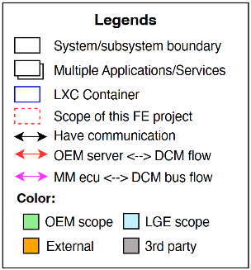
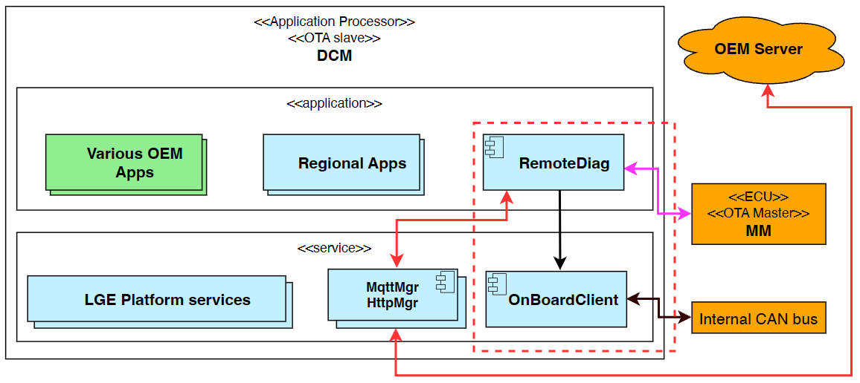
Figure 1: Current architecture

System architecture migration
According to the OEM security threat analysis, the Entry Point (EP) partition may be compromised by unauthorized or malicious software, resulting in a takeover of the externally exposed environment. In a monolithic deployment, such a compromise could allow an attacker to access components responsible for vehicle-internal communication, increasing the risk of unauthorized access to the in-vehicle CAN network and other critical vehicle assets.
To mitigate this threat, the OEM security requirement specifies that any security compromise shall be contained within the Entry Point domain and shall not propagate to vehicle-internal resources. Specifically, a compromise of externally exposed components must not provide direct access to the Internal partition or the in-vehicle CAN bus.
EP partition: contains components that communicate with external networks, including OEM center server. Due to its external exposure, the EP domain is considered the primary attack entry point and therefore has a higher security risk.
Internal partition: contains components that interact with vehicle-internal resources, including the CAN bus and vehicle ECUs. This domain is responsible for vehicle-internal operations and requires protection from externally exposed attack vectors.
To satisfy this requirement, the DCM architecture is migrated from a monolithic deployment to a containerized architecture using LXC containers:
- EP Container (Entry Point Container) hosts externally exposed network-facing components that communicate with OEM cloud services and external networks.
- Internal Container hosts vehicle-internal components that require access to the CAN bus and other internal vehicle resources.
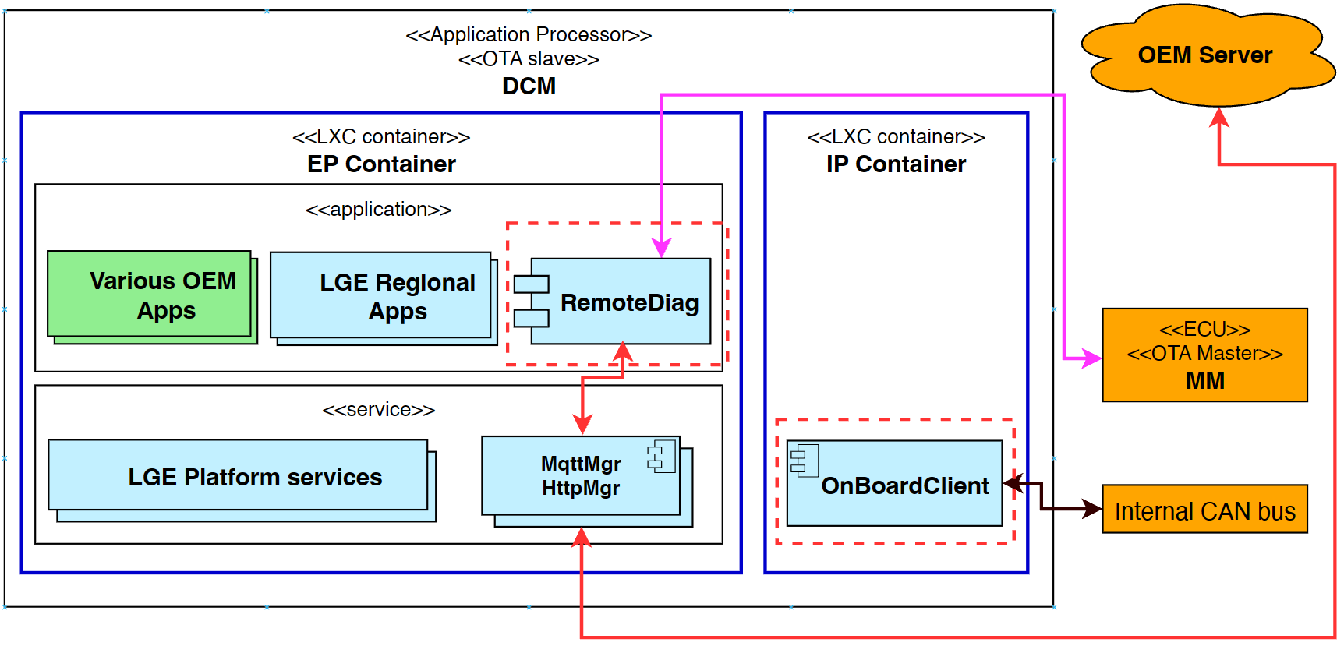
Figure 2: New architecture (containerized)

Problem

Functional requirements
Table 5: Functional requirements
# | Description
FR-01 | The system shall block unauthorized diagnostic commands related to ECU reprogramming.
FR-02 | The system shall route UDS diagnostic messages exchanged with the MM ECU entirely within the IP.

Problem identification

Problem description
RemoteDiag is a module that processes diagnostics for each ECU and uploads diagnostic data to the OEM Server. It has 2 communication paths:
- with OEM Server: performs direct diagnostic commands.
- with MM ECU: OTA diagnostic update.
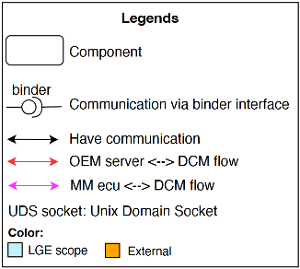
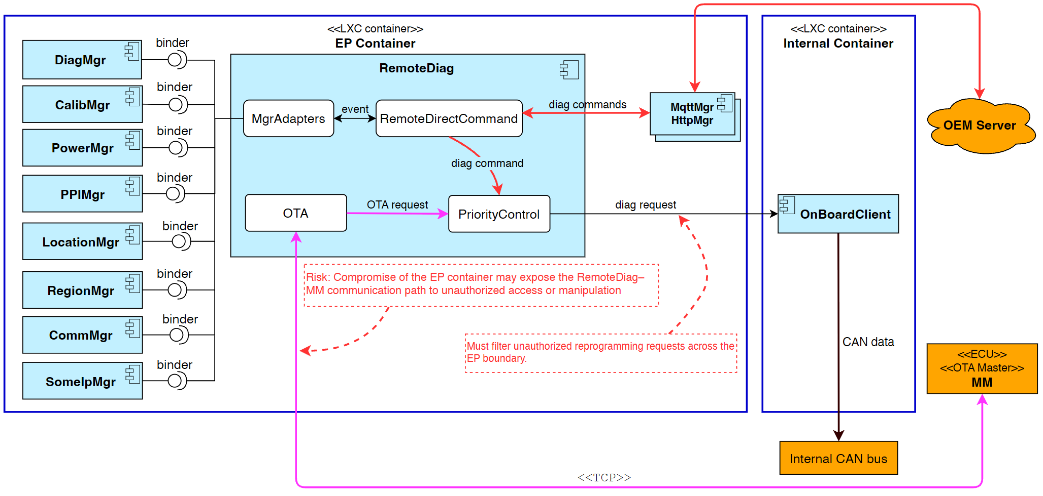
Figure 3: RemoteDiag communication paths
There is a risk that the RemoteDiag ↔ MM path routes through the EP, which is exposing the communication to an attacker when EP container is compromised. And OEM requests that unauthorized reprogramming requests should be filtered. Therefore, RemoteDiag’s internal architecture and communication should be redesigned to align with the new architecture.

Problem analysis
The EP container hosts externally exposed network components (MqttMgr, HttpMgr and other applications, etc.). If the EP container is compromised, an attacker can inject reprogramming diagnostic requests toward the internal CAN bus through RemoteDiag’s existing communication paths.
The MM ECU OTA diagnostic flow (TCP) currently terminates in the EP container, violating the requirement that diagnostic traffic with the MM ECU must be handled entirely within the IP container.
Therefore the design must (1) filter reprogramming-related SIDs before they reach the internal CAN bus, and (2) relocate the MM ECU diagnostic endpoint into the IP container, while minimizing the impact on the 10+ existing EP-side manager modules that communicate with RemoteDiag over binder IPC.

Quality Attributes
The following quality attributes were carefully considered and prioritized while redesigning RemoteDiag. These attributes guided the architectural decisions and solution selection:
Table 6: Quality Attributes

ID | QA Scenario | Measure | Type | Priority
QA-01 | A compromised app/service sends reprogramming diagnostic to CAN | Zero Reprogramming SIDs reaches the internal CAN. | Security | High
QA-02 | MM ECU sends a diagnostic request via TCP to RemoteDiag | Zero diagnostic communication is found in EP.  100% of requests are handled within IP. | Security | High
QA-03 | A new design reallocates responsibilities among existing software components. | No component is required to take responsibilities outside its originally defined role.  No additional specification updates caused by responsibility expansion. | Modifiability | High
QA-04 | A new design requires existing software components (other than RemoteDiag) to adapt to the new architecture. | Number of component which needs to modify to align with new design | Maintainability | Medium

Architecture Alternatives

Alt-A: Split RemoteDiag
Split RemoteDiag responsibilities into 2 apps:
- RemoteDiag (EP): handles diag messages from OEM server.
- RemoteOTA (IP): handles OTA diag message flows from MM ECU.
- OnBoardClient is responsible for reprogramming message filtering and diagnostic priority control.
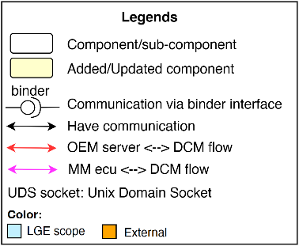
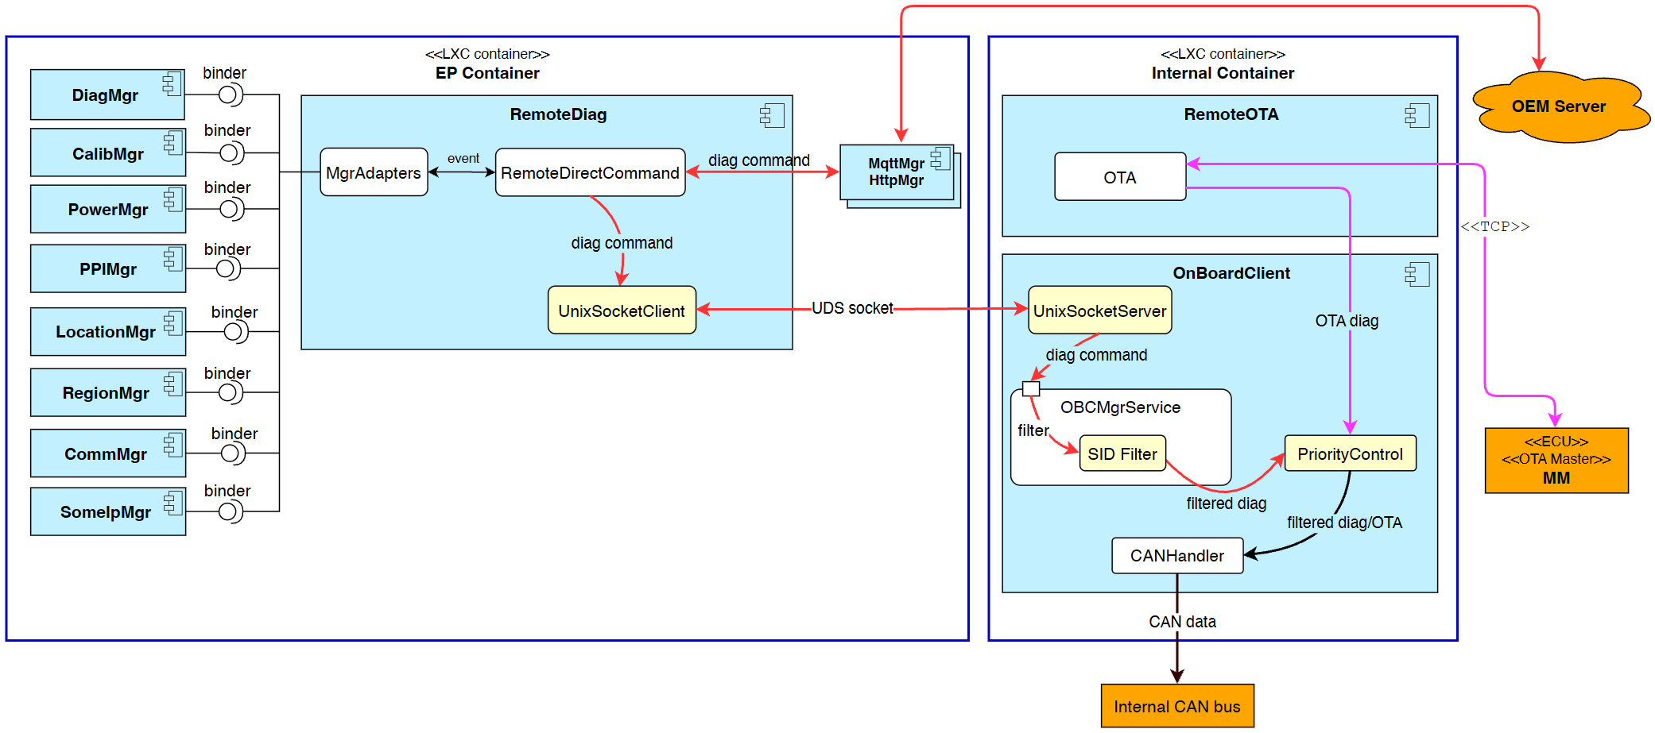
Figure 4: Alt-A — Split RemoteDiag

Alt-B: Move RemoteDiag
- Move RemoteDiag into the IP container.
- To maintain communication with the OEM server and other EP-side components, establish UDS socket connections to each module.
- Trade-off:
  - Maintainability: All EP modules require cross-container IPC support, increasing implementation effort and code-change scope.
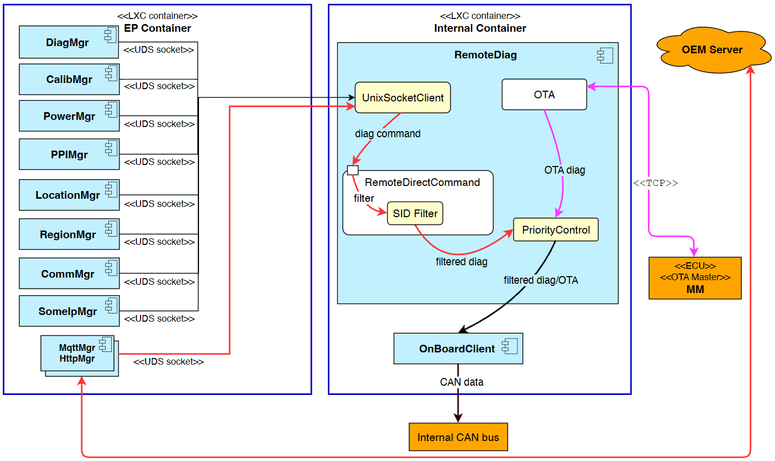
Figure 5: Alt-B — Move RemoteDiag

Alt-C: Move RemoteDiag + Proxy
- Move RemoteDiag into the IP container.
- Add a new RemoteDiagProxy (RDP) component in the EP that acts as a transparent proxy:
  - EP modules continue to interact with RDP using their existing interface.
  - RDP forwards requests to RemoteDiag via a UDS socket channel.
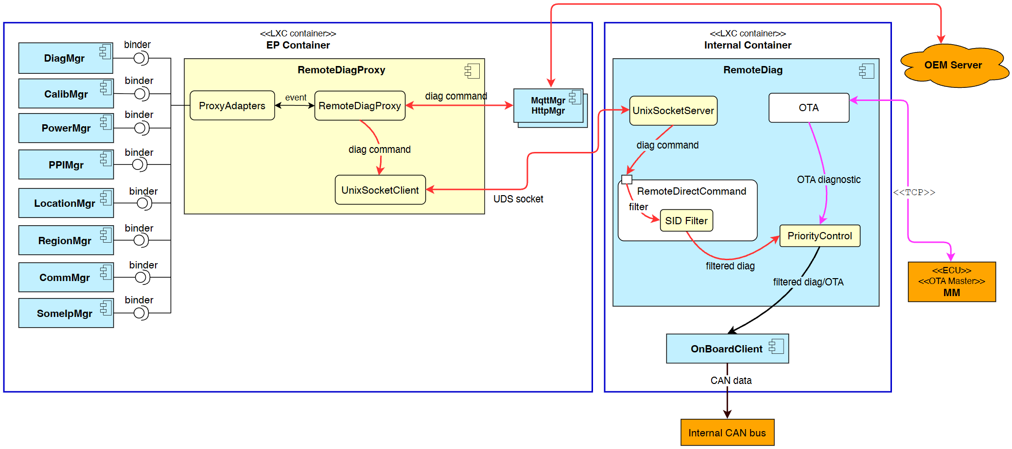
Figure 6: Alt-C - Move RemoteDiag + Proxy

Comparison and decision
Consider the table to see the comparison of the designs:
Table 7: Comparison of architecture alternatives
 | Alt-A – Split RemoteDiag | Alt-B – Move RemoteDiag | Alt-C – Move RemoteDiag + Proxy
QA-01  Security | High  Unauthorized diagnostic commands are filtered. | High  Unauthorized diagnostic commands are filtered. | High  Unauthorized diagnostic commands are filtered.
QA-02  Security | High  MM ECU diagnostic traffic remains within the EP container. (CyberSecurity team confirmed) | High  MM ECU diagnostic traffic remains within the EP container. (CyberSecurity team confirmed) | High  MM ECU diagnostic traffic remains within the EP container. (CyberSecurity team confirmed)
QA-03 Modifiability | Low  RemoteDiag and OnBoardClient’s responsibility is changed:  - Diagnostic priority control is moved to OnBoardClient which requires requirement updates.  - Existing RemoteDiag responsibilities are distributed across two applications, increasing OEM specification and coordination effort | High  Core responsibilities of existing components remain unchanged after migration. | High  Core responsibilities of existing components remain unchanged after migration.
QA-04 Maintainability | Medium  01 additional component is modified (OnBoardClient — implements UDS socket server and priority control). | Low  10 EP modules (PowerMgr, HttpMgr, …) have to implement cross-container UDS socket communication and fail-safe handling. | Medium  No changes required in existing modules but a new module RemoteDiagProxy is required.  RemoteDiagProxy preserves the current binder interface.
Decision | Rejected | Rejected | Selected

Rating: High = Fully satisfy · Medium = Partially satisfy · Low = Not satisfy

Key Decision Factors:
- Security: All three alternatives satisfy QA-01 and QA-02.
- Modifiability: Alt-B and Alt-C preserve the core responsibilities of the existing components; Alt-A changes the responsibilities of RemoteDiag and OnBoardClient.
- Maintainability: Alt-C requires no changes in existing modules — RemoteDiagProxy preserves the current binder interface, whereas Alt-B forces 10 EP modules to implement cross-container UDS socket communication.

Selected design: Alt-C — Move RemoteDiag + Proxy

Implementation and Verification

Implementation

Forward API call
- Callback transmission from the RemoteDiagProxy to RemoteDiag in the IP container:
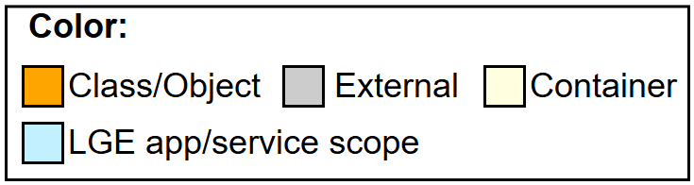
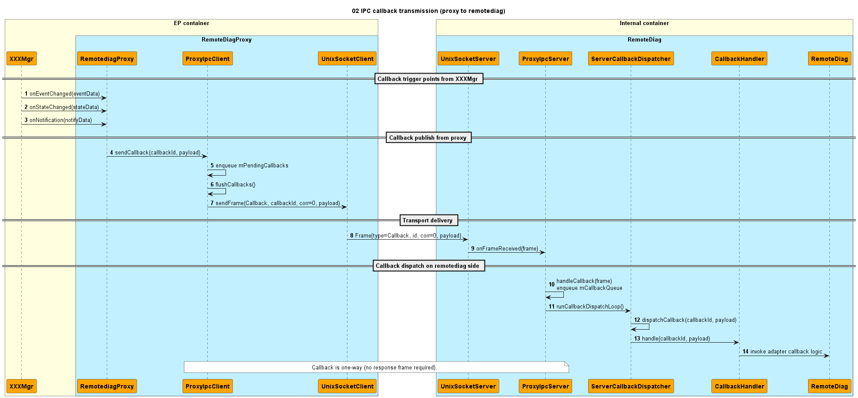
Figure 7: IPC callback transmission (proxy to remotediag)

- API request-response from RemoteDiag back to the proxy:
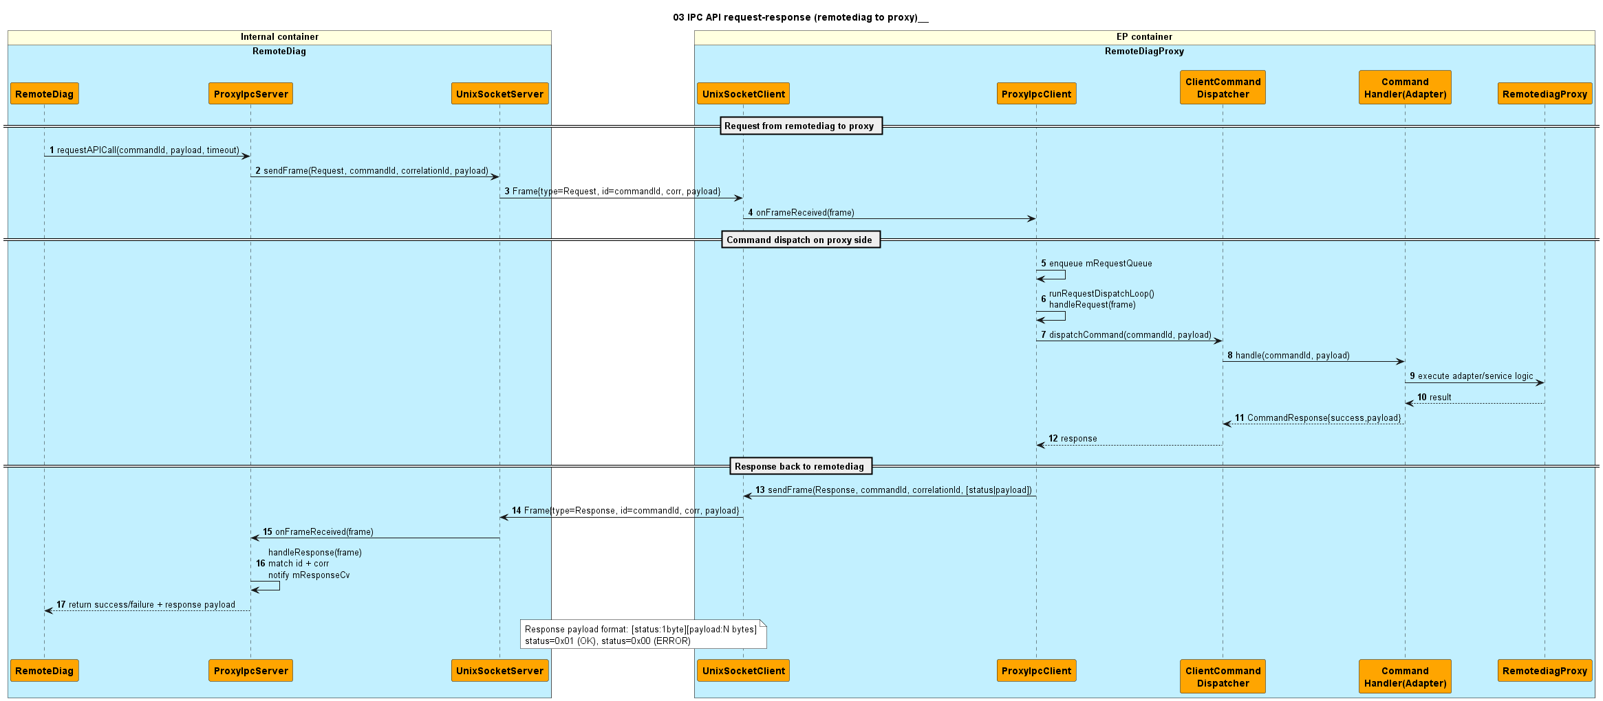
Figure 8: IPC API request-response (remotediag to proxy)

Filter scenario
The diagnostic filter scenario inside the IP container: RemoteDirectCommand validates each direct command and consults SidFilter before pushing the UDS request toward the internal CAN bus.
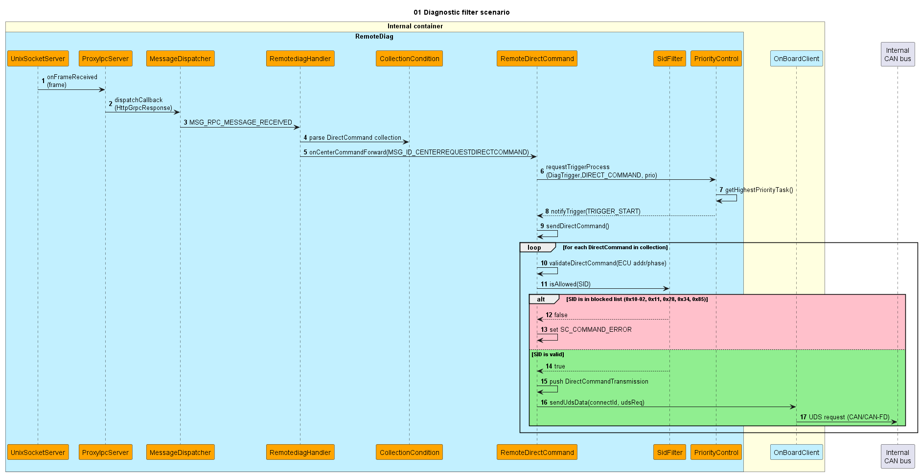
Figure 9: Diagnostic filter scenario

Verification

SidFilter blocks reprogramming diagnostic requests
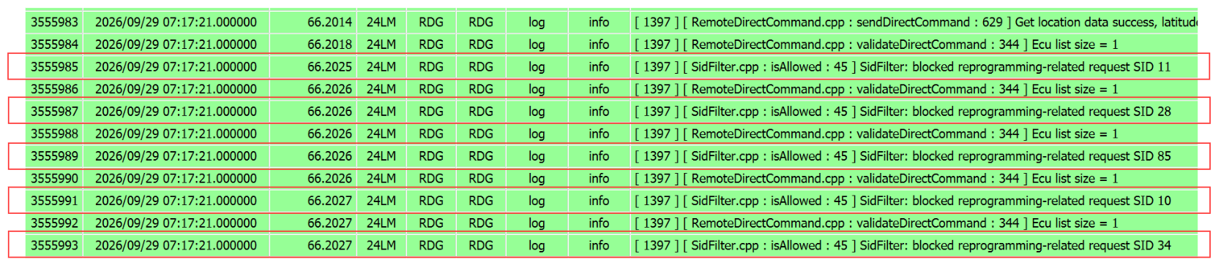
Figure 10: Runtime log — SidFilter rejects reprogramming-related SIDs

RemoteDiagProxy and RemoteDiag communication
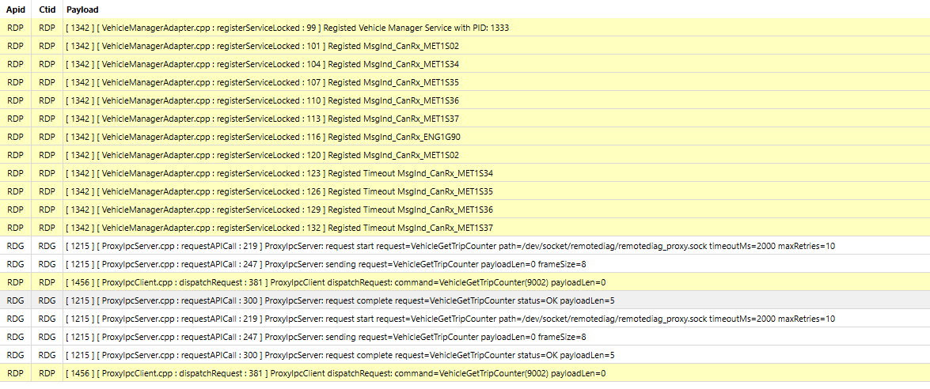
Figure 11: Runtime log — proxy IPC request/response across the UDS socket

Conclusion
The evaluation of three architecture alternatives (Split RemoteDiag, Move RemoteDiag, and Move RemoteDiag + Proxy) determined that Alt-C — moving RemoteDiag into the IP container together with a transparent RemoteDiagProxy in the EP container — provides the best balance of security, modifiability, and maintainability. Verification results confirm that both functional requirements are satisfied: SidFilter blocks all reprogramming-related SIDs (FR-01), and MM ECU diagnostic communication is handled entirely within the IP container (FR-02), while existing EP modules continue to use their unchanged binder interfaces through the proxy.

Appendix

Diagnostic filtering requirements
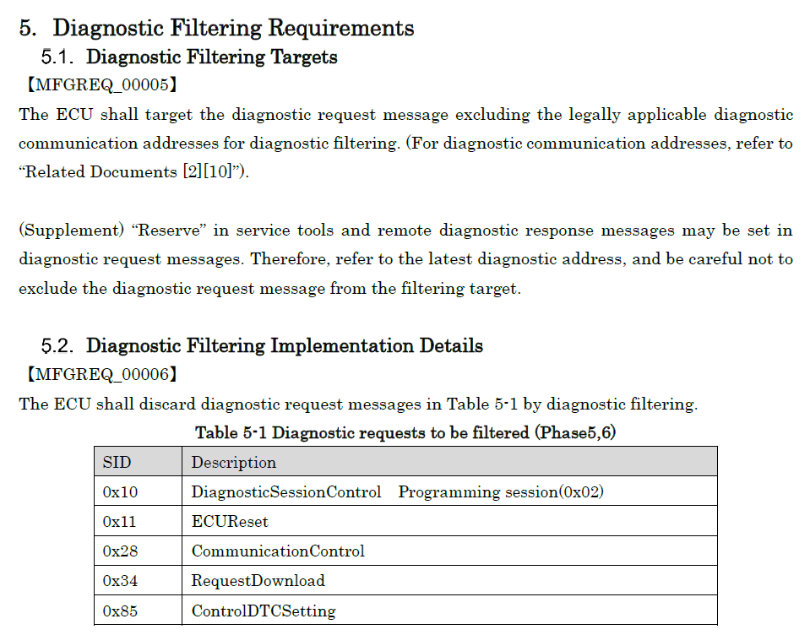
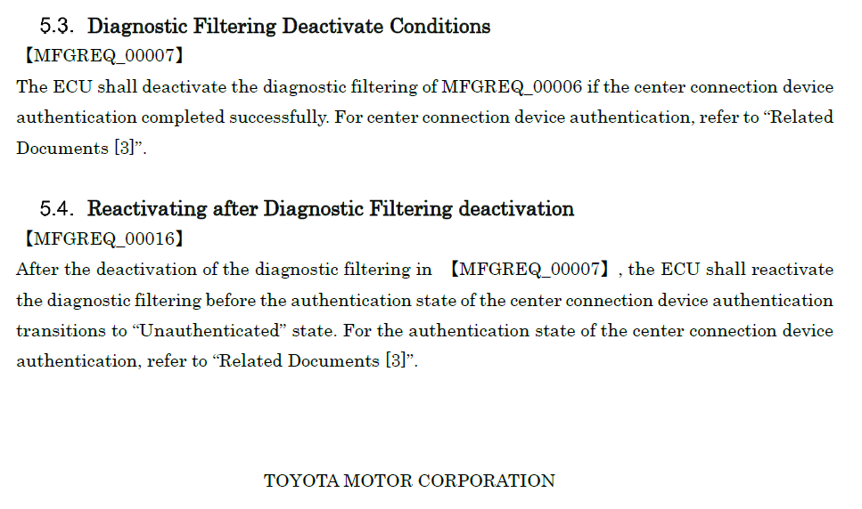

Additional sequence diagrams
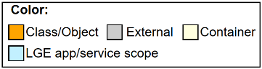
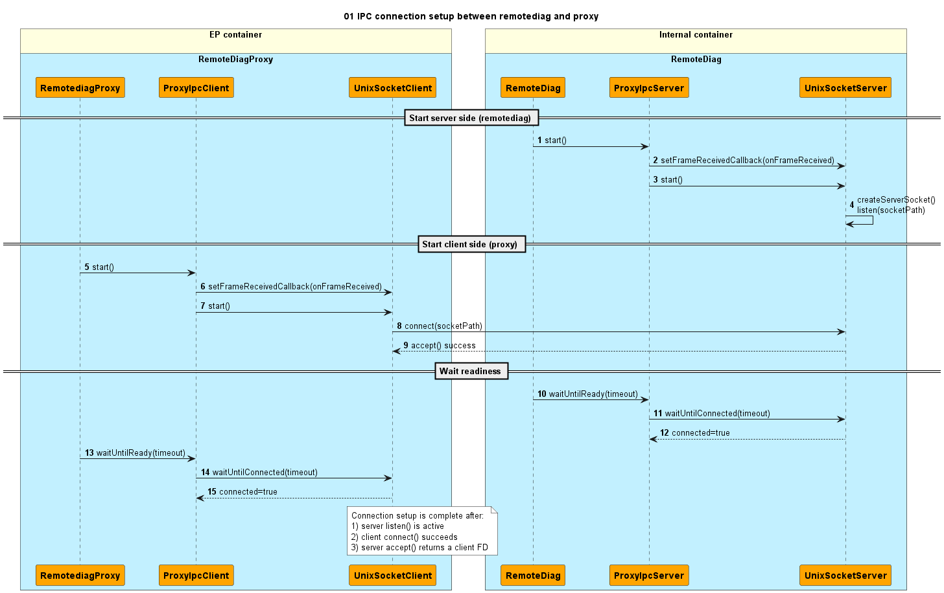
Figure 12: IPC connection setup RemoteDiagProxy - RemoteDiag

Figure 13: IPC API request - response
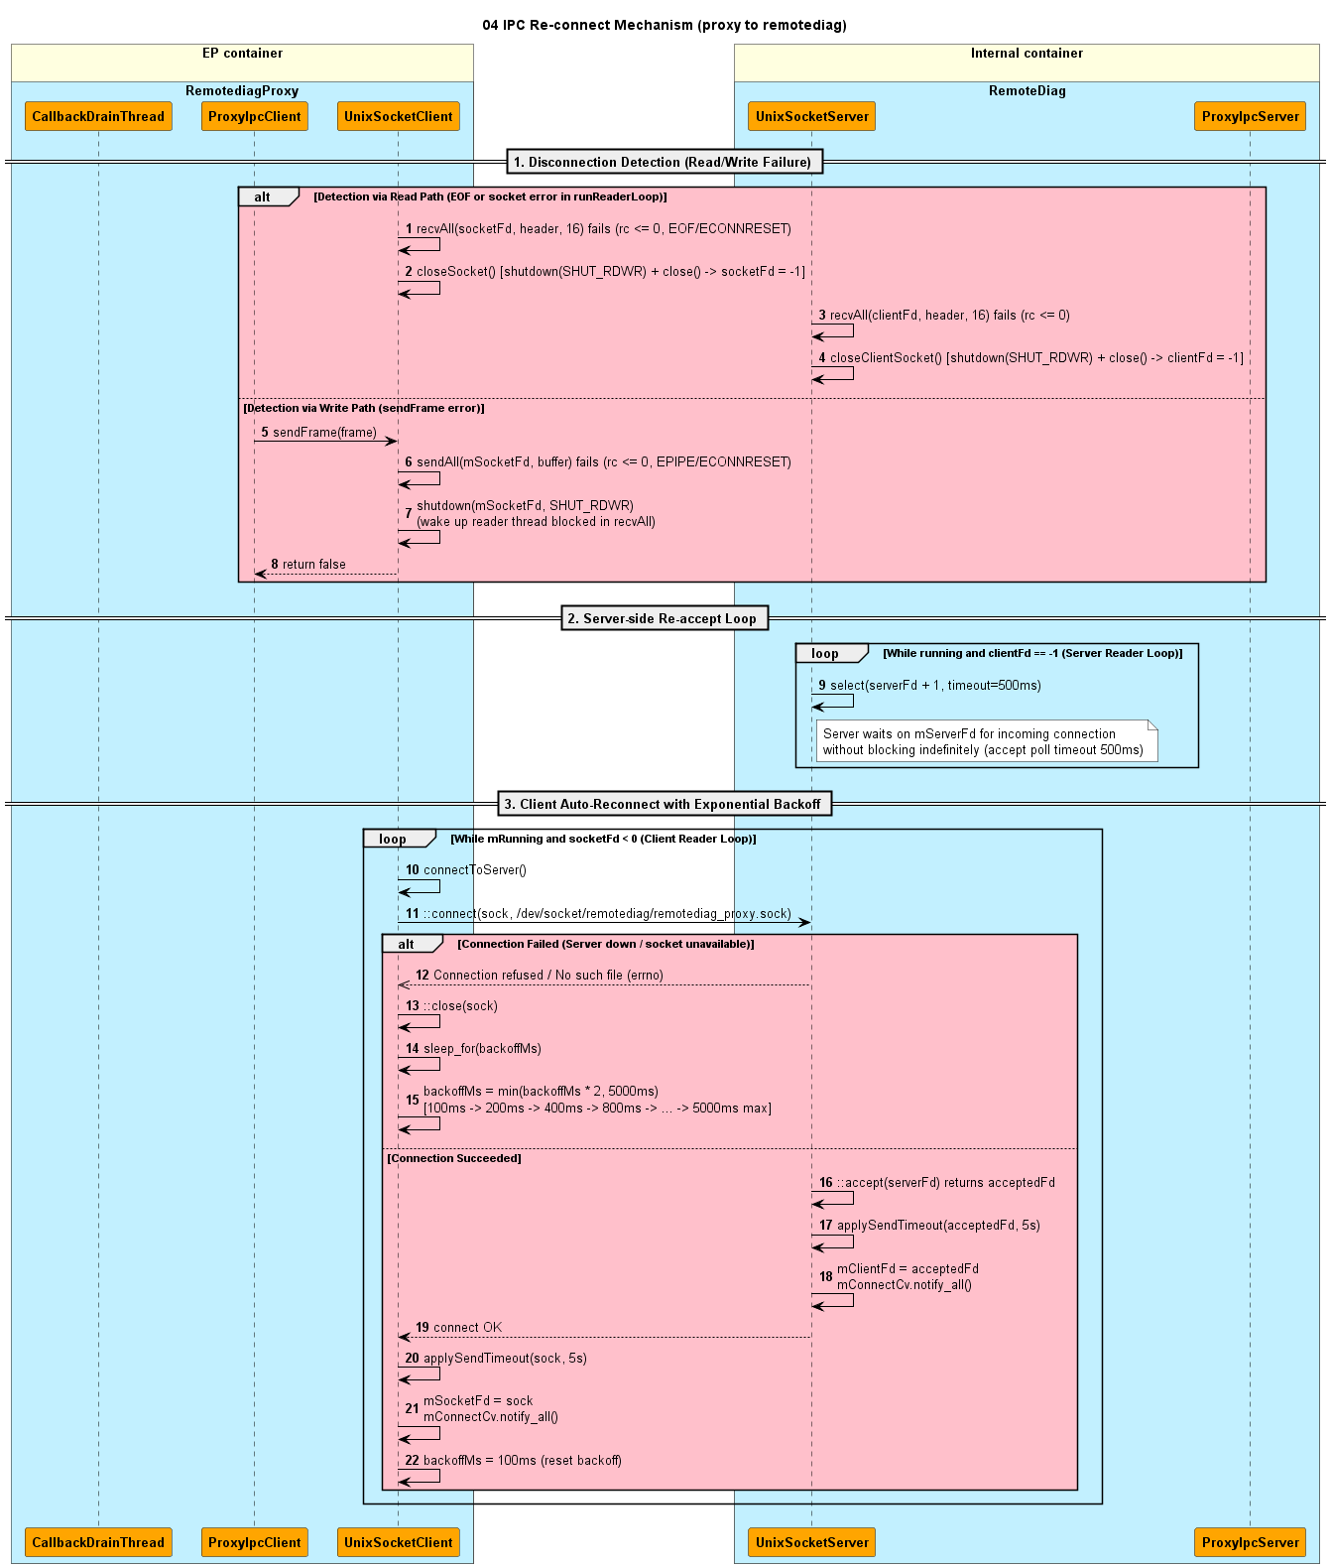
Figure 14: 1 - IPC re-connect mechanism
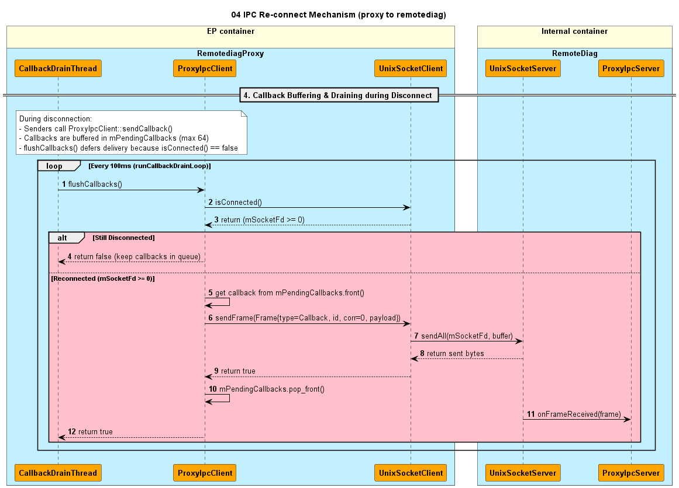
Figure 15: 2 - IPC re-connect mechanism

